Basic Git workflow for setting up a new Project on GitHub

**PURPOSE OF DOCUMENT:**

The purpose of this document is to provide a usage overview for individuals who are new to using GitHub for version control. The document offers basic instructions for uploading documents to GitHub, which beginners can copy and follow to perform basic operations.

**AUDIENCE:**

The primary audience of the document is beginners who use GitHub on Mac computers.

**SCOPE AND OBJECTIVES:**

This process document aims to provide an overview and step-by-step guidance for beginners using GitHub on Mac computers. It covers basic instructions for starting a new project, installing Git on a local Mac computer, updating documents using Git, linking a local folder to a GitHub project, and pushing changes from a local Git repository to a GitHub project. The document targets individuals who are new to GitHub and are seeking fundamental instructions to perform basic operations.

**STEPS：**

1. **Create a Local txt Document**

Create a txt document on my desktop, named ‘exercise.txt’.

1. **Initialize a Git Repository:**

2.1. Open the Terminal, and Navigate to the directory where "exercise.txt" is located:

Use “cd ~/Desktop” command

then Use “ls”command

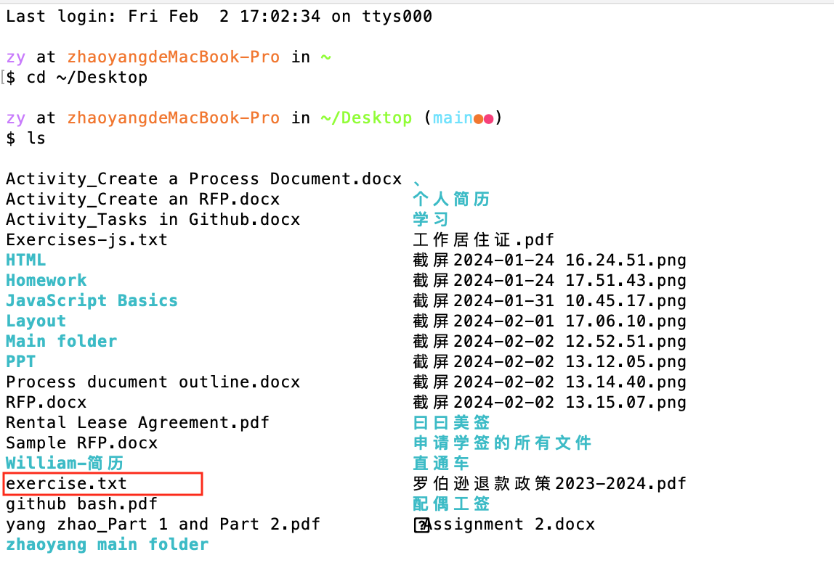

2.2. Initialize the Git repository.

Execute the command :$ git init

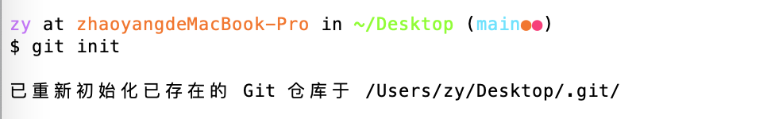

1. **Add some changes in txt.**

Open the txt with VScode, and add some changes

1. **Use Git commands to stage changes**

**Problems encountered：**I stored exercise.txt in desktop, but the terminal showed me the wrong path, it showed the txt was in my ‘JavaScript basics folder. Then I puted it in ‘yang_yang’ folder, and re-executed the command：



1. **Commit changes**

Execute the “git commit -m “ Add exercise.txt” command to commit the changes:

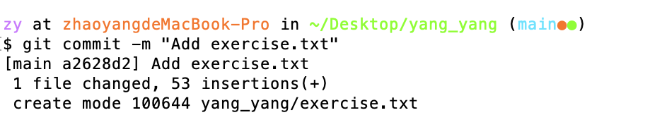

I have successfully committed the changes and created a commit record that contains the addition of "exercise.txt".

1. **Rollback to Initial Snapshot**

Execute the “git log” command to find my initial commit ID:

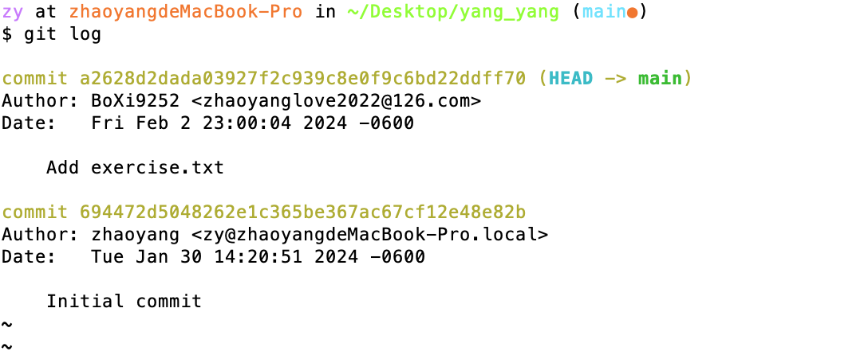

Execute the following command to rollback the initial snapshot:

git checkout <initial commit ID> -- exercise.txt

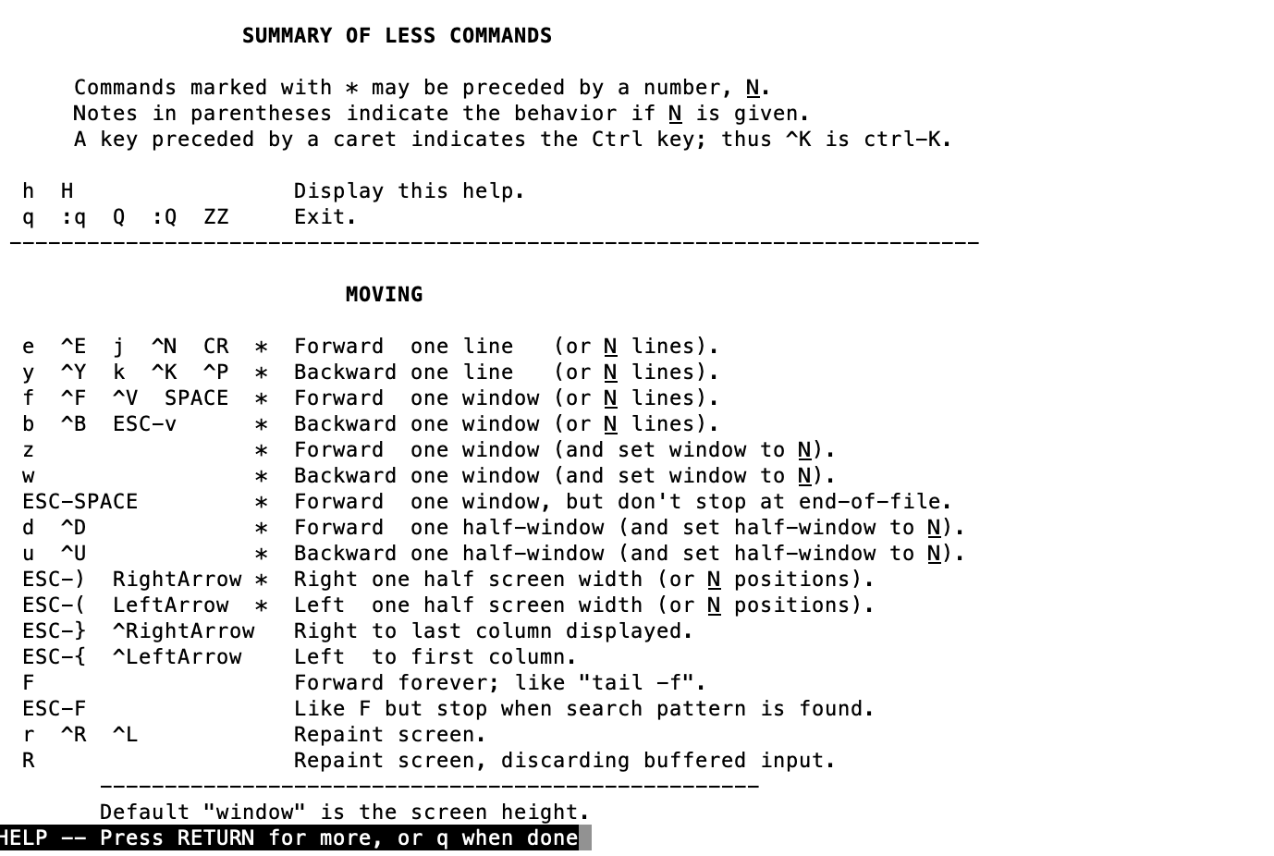

1. **Create a new repository on GitHub**
   1. Log in GitHub , and create a repository



7.2.Link my local Git repository to the GitHub repository:

find the URL in the GitHub repository, and copy the URL to the commit:

git remote add origin +URL



7.3.Push my changes to GitHub:

Create the token on GitHub to meet the User Authentication.

7.4.Push local repository to remote repository on GitHub.

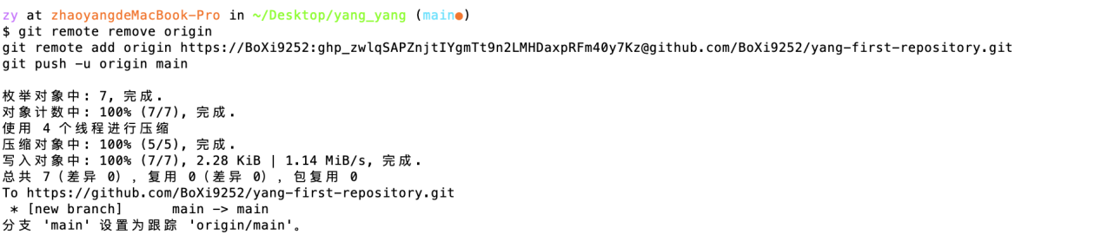

**REVISION HISTORY:**

|  |  |  |  |  |
| --- | --- | --- | --- | --- |
| **Version** | **Date** | **Reviewed By** | **Changes Made By** | **Summary of Changes** |
| 1.0 | 2024-01-06 | Yang Zhao | Yang Zhao | Complete the initial document based on the actual operation process； |
| 1.1 | 2024-01-10 | Yang Zhao | Yang Zhao | Improve the basic structure of the process document, add information such as purpose and audience; |
| 1.2 | 2024-01-10 | Lu Liu | Yang Zhao | Revise some document structures, grammar, and expressions to make the document clearer and more readable. |

**ORIGINAL CONTENT LINKS Of GitHub:**